**Developing a Comprehensive Churn Prediction and Retention System at XYZ Bank**

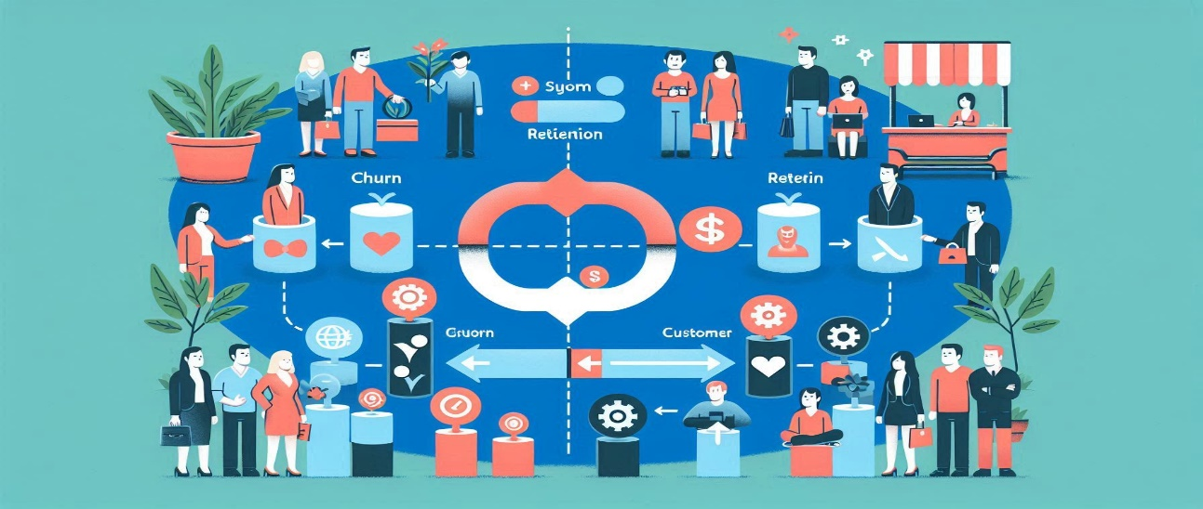

**Problem Statement**: As an AI/ML engineer, you are tasked with developing a comprehensive churn prediction and retention system for our company. Your objective is to design and implement a solution that addresses the following components:

* **Predictive Models for Churn Analysis:** Analysing customer data to predict which customers are at risk of leaving and identifying factors contributing to churn.
* **NLP for Customer Feedback Analysis:** Understanding reasons for dissatisfaction by analysing textual feedback from surveys, complaints, and social media.
* **Generative AI for Retention Strategies:** Developing and testing personalized retention strategies and communication plans to reduce churn rates.

**Solution:**

* Develop a well-structured solution architecture utilizing the proposed techniques.
* Showcase the functionality of solution and its potential impact.

**Dataset:** For this assignment, you will work with the following datasets: Attached.

**Task Requirements:**

a) Data Understanding and Preprocessing:

* Examine the provided datasets and describe their structure.
* Identify relevant features for churn prediction.
* Propose and implement necessary data cleaning and preprocessing steps.
* Handle missing values and outliers appropriately.
* Perform exploratory data analysis to gain insights.

b) Predictive Models for Churn Analysis:

* Select and justify appropriate machine learning algorithms for churn prediction.
* Implement feature engineering techniques to improve model performance.
* Develop at least two different models.
* Evaluate and compare model performance using relevant metrics.
* Identify the most important features contributing to churn.

c) NLP for Customer Feedback Analysis:

* Preprocess textual data from customer feedback.
* Implement sentiment analysis to gauge overall customer satisfaction.
* Develop a method to extract key insights and reasons for dissatisfaction.

d) Generative AI for Retention Strategies:

* Propose an approach for using generative AI to create personalized retention strategies. Use the models as per your convenience.
* Develop a system to generate tailored communication plans based on customer profiles and churn risk.
* Implement a method to evaluate and refine generated strategies.
* Describe how you would integrate this component with the predictive model and NLP analysis.

e) System Integration and Deployment:

* Outline an architecture for integrating all components into a cohesive system.
* Propose a deployment strategy (e.g., cloud-based, on-premises)
* Describe how you would handle real-time data processing and model updates.
* Discuss potential scalability challenges and how to address them.

f) ) Ethical Considerations and Privacy:

* Discuss potential ethical implications of the churn prediction system.
* Propose measures to ensure customer privacy and data protection.
* Address any potential biases in the model and how to mitigate them.

**Deliverables:**

* Jupyter notebook(s) with complete solution that provide entire workflow, from data loading, EDA, FE to Model building and deployment code with clear comments and explanations.
* Python scripts for your final implementation.
* A presentation (maximum 10 slides) summarizing your approach, key findings, and recommendations for stakeholders.
* Requirements.txt file listing all necessary libraries and their versions.